***Ripunjay Narula (19BCE0470)***

1. import java.util.Scanner;

public class sum_row

{

public static void main(String[] args) {

int r, c, sum;

Scanner sc=new Scanner(System.in);

System.out.println("Enter the number of rows: ");

r=sc.nextInt();

System.out.println("Enter the number of columns: ");

c=sc.nextInt();

System.out.println("Enter array elements : ");

int m[][]=new int[r][c];

for(int i=0; i<r;i++)

{

for(int j=0; j<c;j++)

{

m[i][j]=sc.nextInt();

}

}

for(int i = 0; i < r; i++){

sum = 0;

for(int j = 0; j < c; j++){

sum = sum + m[i][j];

}

System.out.println("Sum of row " + (i+1) +": " + sum);

}

}

}

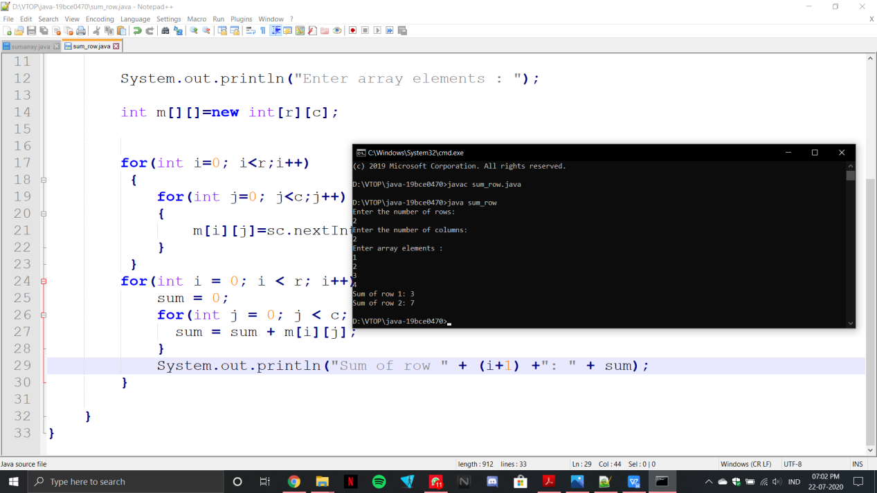

1. import java.util.Scanner;

public class sumarray

{

public static void main (String[]args)

{

Scanner sc = new Scanner (System.in);

System.out.println ("Enter number of rows for m1: ");

int r1 = sc.nextInt ();

System.out.println ("Enter number of columns for m1: ");

int c1 = sc.nextInt ();

int[][] m1 = new int[r1][c1];

System.out.println ("Enter number of rows for m2: ");

int r2 = sc.nextInt ();

System.out.println ("Enter number of columns for m2: ");

int c2 = sc.nextInt ();

int[][] m2 = new int[r2][c2];

System.out.println ("Enter number of rows for m3: ");

int r3 = sc.nextInt ();

System.out.println ("Enter number of columns for m3: ");

int c3 = sc.nextInt ();

int[][] m3 = new int[r3][c3];

for (int i = 0; i < r1; i++)

{

for (int j = 0; j < c1; j++)

{

m1[i][j] = sc.nextInt();

}

}

for (int i = 0; i < r2; i++)

{

for (int j = 0; j < c2; j++)

{

m2[i][j] = sc.nextInt();

}

}

for(int i=0;i<r3;i++){

for(int j=0;j<c3;j++){

m3[i][j]=m1[i][j]+m2[i][j];

System.out.print(m3[i][j]+" ");

}

}

}

}

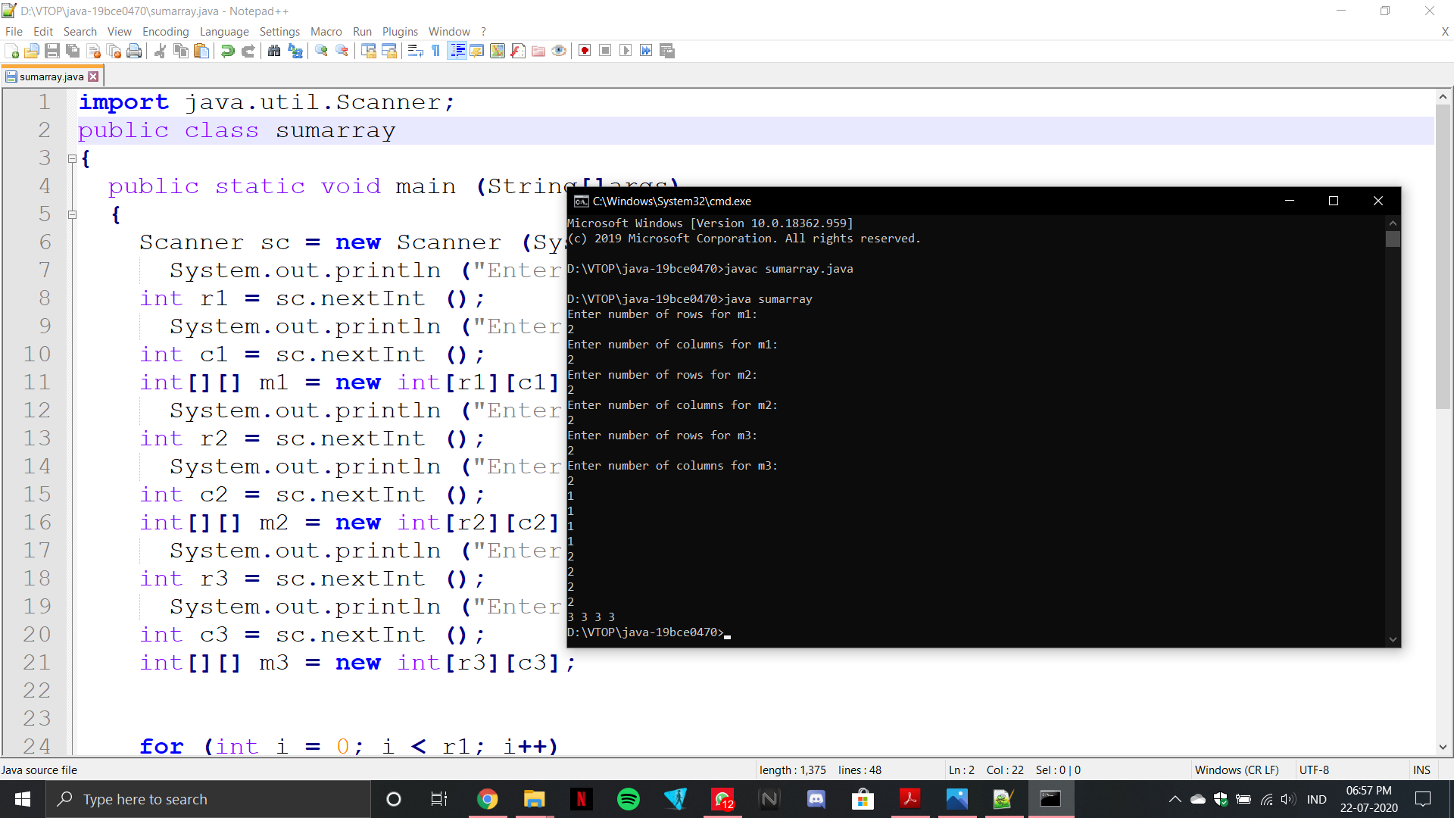

6.import java.util.Scanner;

public class Main {

public static void main(String[] args)

{

Scanner sc= new Scanner(System.in);

System.out.println("Enter number of elements in the array: ");

int n= sc.nextInt();

System.out.println("Enter elements in the array: ");

int arr[]= new int[n];

for (int i = 0; i < n; i++)

{

arr[i]=sc.nextInt();

}

int[] temp = new int[n];

int j = 0;

for (int i=0; i<n-1; i++){

if (arr[i] != arr[i+1]){

temp[j++] = arr[i];

}

}

temp[j++] = arr[n-1];

for (int i=0; i<j; i++){

arr[i] = temp[i];

}

System.out.println("New Array elements are: ");

for (int i = 0; i<array_sort(arr); i++)

{

System.out.print(arr[i]+" ");

}

System.out.println("\nThe new length of the array is: "+array_sort(arr));

}

public static int array_sort(int[] arr)

{

int index = 1;

for (int i = 1; i<arr.length; i++) {

if (arr[i] != arr[index-1])

arr[index++] = arr[i];

}

return index; }

}